**CATALOGUE**

**SIGUREN UNIT®**

**"Motosuiveur®" (MS)**

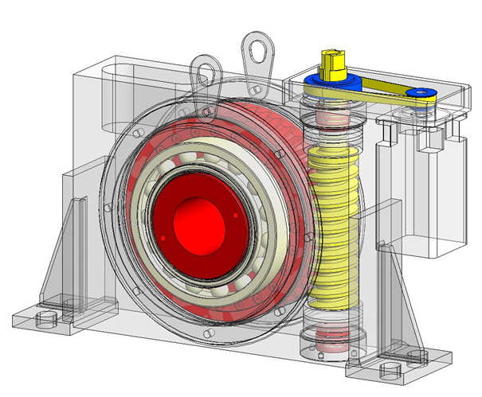

***Crane application***

*July 2014*

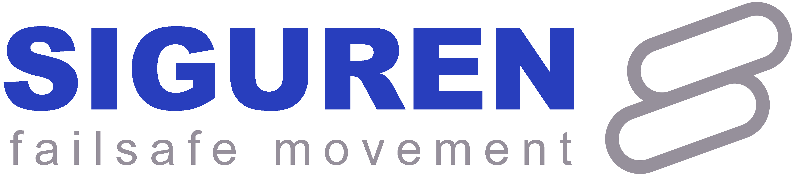

**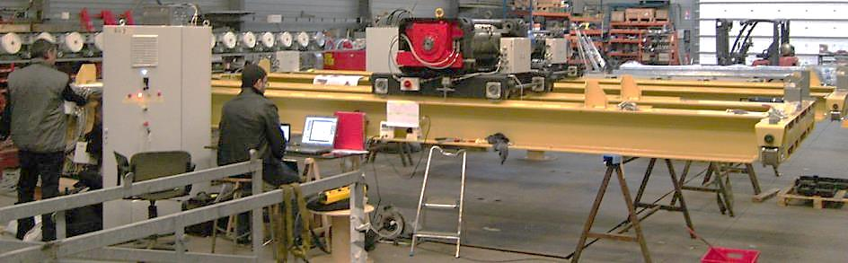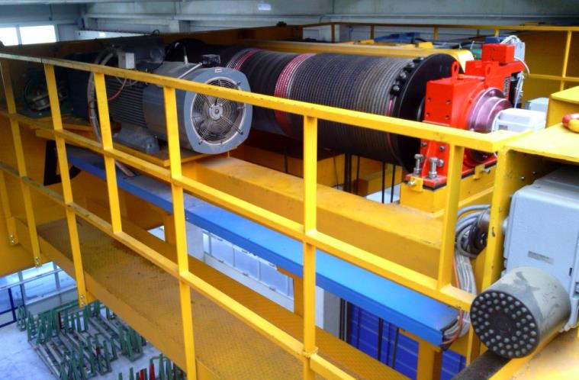**

**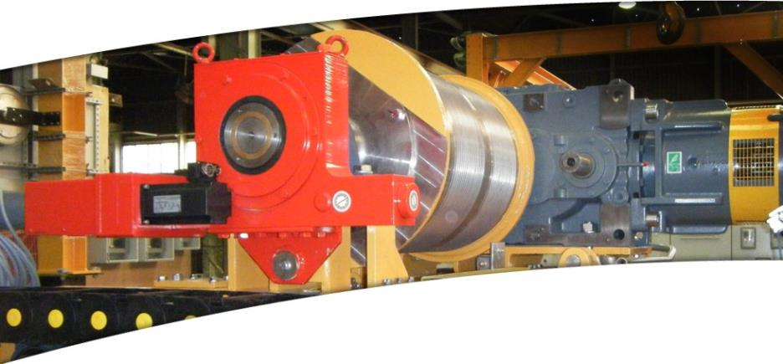**

[1 PRESENTATION OF SIGUREN UNIT® 5](#_Toc391561667)

[1.1 APPLICATION OF SIGUREN UNIT® 5](#_Toc391561668)

[1.2 OPERATING PRINCIPLE 6](#_Toc391561669)

[1.3 TWO VERSIONS 7](#_Toc391561670)

[1.4 GENERAL DESCRIPTIONS OF THE SIGUREN UNIT 7](#_Toc391561671)

[1.4.1 Mechanical part 7](#_Toc391561672)

[1.4.2 Electrical part 8](#_Toc391561673)

[1.5 FUNCTIONAL STATES 9](#_Toc391561674)

[1.5.1 At Stop 10](#_Toc391561675)

[1.5.2 Follow-up 10](#_Toc391561676)

[1.5.3 Electrical or mechanical failure 11](#_Toc391561677)

[1.5.4 Overspeed 11](#_Toc391561678)

[1.5.5 Recovery 12](#_Toc391561679)

[2 HOW TO SELECT YOUR SIGUREN UNIT® 13](#_Toc391561680)

[2.1 SIGUREN UNIT® TYPE SELECTION DIAGRAM 13](#_Toc391561681)

[2.2 HYDRAULING DAMPING SIGUREN UNIT® 14](#_Toc391561682)

[2.3 PASSIVE FRICTION SIGUREN UNIT® 14](#_Toc391561683)

[3 SIGUREN UNIT® SIZE 15](#_Toc391561684)

[4 CODIFICATION 16](#_Toc391561685)

[5 SIGUREN UNIT® TYPE 18](#_Toc391561686)

[5.1 HYDRAULIC DAMPING SIGUREN UNIT® 18](#_Toc391561687)

[5.2 PASSIVE FRICTION SIGUREN UNIT® 18](#_Toc391561688)

[6 RECOVERY 18](#_Toc391561689)

[7 MOUNTING TYPE 19](#_Toc391561690)

[7.1 HYDRAULIC DAMPING SIGUREN UNIT® 19](#_Toc391561691)

[7.2 PASSIVE FRICTION SIGUREN UNIT® 20](#_Toc391561692)

[8 DIRECTION CHOICE OF THE ROTATION AT LOWERING 21](#_Toc391561693)

[8.1 CLOCKWISE 21](#_Toc391561694)

[8.2 ANTICLOCKWISE 21](#_Toc391561695)

[9 SIGUREN UNIT® POSITION CHOICE 22](#_Toc391561696)

[9.1 HYDRAULIC DAMPING SIGUREN UNIT® 22](#_Toc391561697)

[9.2 PASSIVE FRICTION SIGUREN UNIT® 22](#_Toc391561698)

[10 SIGUREN UNIT® REACTION ARM POSITION CHOICE 23](#_Toc391561699)

[10.1 HYDRAULIC DAMPING SIGUREN UNIT® 23](#_Toc391561700)

[10.1.1 Position of mounting plate 23](#_Toc391561701)

[10.1.2 Position of reaction arm 23](#_Toc391561702)

[10.1.3 Position of reaction arm support 24](#_Toc391561703)

[10.2 PASSIVE FRICTION SIGUREN UNIT® 25](#_Toc391561704)

[10.2.1 Position of mounting plate 25](#_Toc391561705)

[10.2.2 Feet position 25](#_Toc391561706)

[10.2.3 Position of reaction arm 26](#_Toc391561707)

[10.2.4 Position of reaction arm support 27](#_Toc391561708)

[11 CHOICE OF THE SIGUREN UNIT® DRIVING TYPE 28](#_Toc391561709)

[12 SIGUREN UNIT® MOTOR POSITION CHOICE 28](#_Toc391561710)

[13 OPTIONS 29](#_Toc391561711)

[13.1 RECOVERY MOTOR POSITION 29](#_Toc391561712)

[13.2 TOUCH SCREEN 30](#_Toc391561713)

[13.3 TORQUE LIMITER 31](#_Toc391561714)

[14 DIMENSIONS 32](#_Toc391561715)

[14.1 SIGUREN UNIT® HYDRAULIC DAMPING 32](#_Toc391561716)

[14.1.1 Bearing version 32](#_Toc391561717)

[14.1.2 Shaft mounted with reaction arm on side 34](#_Toc391561718)

[14.1.3 Shaft mounted with reaction arm support 35](#_Toc391561719)

[14.2 PASSIVE FRICTION 36](#_Toc391561720)

[14.2.1 Foot mounted bearing 36](#_Toc391561721)

[14.2.2 Bearing with mounting plate 38](#_Toc391561722)

[14.2.3 Shaft mounted with reaction arm support 40](#_Toc391561723)

[14.2.4 Shaft mounted with reaction on side 41](#_Toc391561724)

[14.3 DRUM SHAFT WITH SPLINES 42](#_Toc391561725)

[15 EXAMPLE OF CALCULATION 43](#_Toc391561726)

[15.1 EXAMPLE N°1–HYDRAULIC DAMPING SIGUREN UNIT® 43](#_Toc391561727)

[15.2 EXAMPLE N°2–PASSIVE FRICTION SIGUREN UNIT® 44](#_Toc391561728)

[16 POSITIONS, TYPES AND OPTIONS EXAMPLES 45](#_Toc391561729)

[17 ELECTRICAL INTERFACE 46](#_Toc391561730)

[17.1 BASIC LINE 46](#_Toc391561731)

[17.2 TOUCH SCREEN LINE 47](#_Toc391561732)

[17.3 RECOVERY LINE 48](#_Toc391561733)

***All indications listed in this catalogue (characteristics and dimensions) are subject to be modified, they can not consitute a commitment from Siguren.***

# PRESENTATION OF SIGUREN UNIT®

## APPLICATION OF SIGUREN UNIT®

**SIGUREN UNIT® (MS) is a hoist safety device, preventing from load drop and overloads in case of electrical or mechanical failure.** Itis designed to protect winches against risks of control loss on the handled load.

**It’s a permissive load arrestor in the event of electrical or mechanical failure.**

This compact self-locking unit :

* Ensures **alone all the safety functions**: load drop, snag load,
* **Eliminates** dynamic overloads and overspeed,
* Negates the need for a secondary safety brake,
* Ensures failsafe operation (alternative actuation path),
* Has an independent load recovery option,
* Range from 10 Kg to 250 tonne cranes,
* No wear parts.

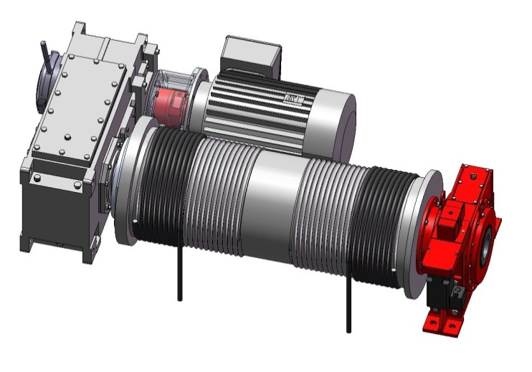

**Torque Limiter**

**Siguren Unit®**

**Drum**

**Gearbox**

**Motor-brake**

**Options :**

* Event monitor (cycles, load spectrum, alarms …)
* Diagnostic aid and preventive maintenance (SWP to FEM 9.755)
* Removable or integrated recovery mechanism, remotely engageable
* Position management

## OPERATING PRINCIPLE

A failsafe mechanical hoist brake, the Motosuiveur® (MS) consists of a worm and wheel gearbox mounted directly to the hoist drum. The worm is a permissive system which allows the wheel and barrel to rotate at any speed within the hoist’s normal operating parameters. Any large differential acceleration between the worm and wheel will cause the system to mechanically lock, safely arresting the load.

This provides mechanical failsafe protection in the event of any electrical or mechanical failure

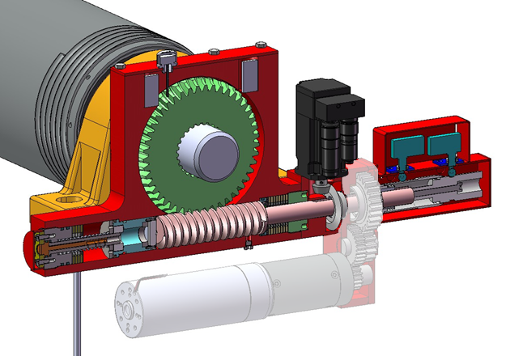

***Drum***

***Worm***

***Wheel***

***Optional recovery motor***

***Servo Motor***





***Drum***

***Worm***

***Wheel***

***Optional recovery motor***

***Servo Motor***

Should an arrest situation occur, the Motosuiveur® absorbs any impact force, bringing the load to a safe drop within 30° rotation of the drum. Dependant on rope and barrel configurations, this could translate to a load drop of as little as just 15mm before arrest.

The incorporation of a Motosuiveur® unit means the reliance on the integrity of the motor, gearbox, drum or shaft is reduced. This allows for the incorporation of a torque limiter between the motor and gearbox which gives mechanical protection against any overload, for example in the event of a snagged load or double blocking.

With an arrested load held by the worm and wheel, an optional integrated independent recovery motor is able to drive the worm to remotely recover the arrested load.

## TWO VERSIONS



***Drum***

***Worm***

***Wheel***

***Optional recovery motor***

***Servo Motor***

There are two types of SIGUREN UNIT®:

* **Damping (Hydraulic or Elastomer):**

its main feature is the constant braking distance, which is limited by design to approximately 30° of rotation of the drum (or on SIGUREN UNIT**®** wheel),

Usually, Hydraulic Damping version must be used with a torque limiter in the hoist power train, providing absolute safety against dynamic overloads

* **Passive Friction - with or without Torque Limiter (TL):**

its main feature is the factory set braking torque.

## GENERAL DESCRIPTIONS OF THE SIGUREN UNIT

A classic winch equipped with a SIGUREN UNIT® is typically made up of the following main parts:

### Mechanical part

Gear box

Drum

**Main kinematic chain**

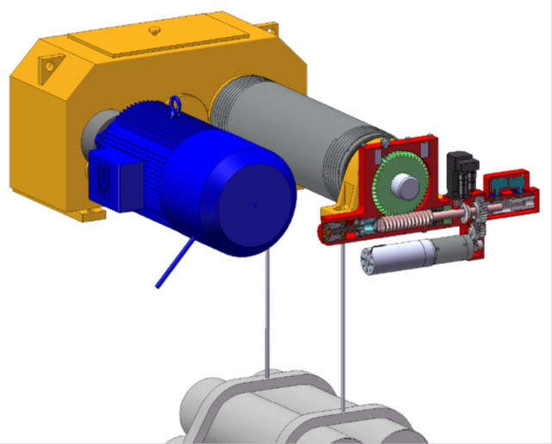

**Safety kinematic chain**

**SIGUREN UNIT®**

Motor

Torque limiter

Recovery mech. (option)

Worm screw

Wheel

Brake Motor

Hydraulic damping chamber

*Figure 1: Winch equipped with hydraulic damping SIGUREN UNIT®*

### Electrical part

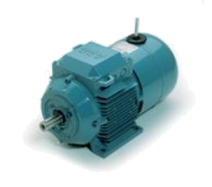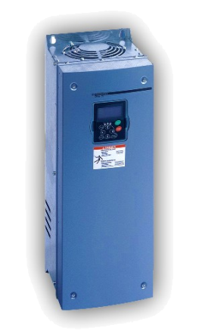

SIGUREN UNIT® Power Supply

Control

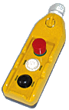

SIGUREN UNIT® PANNEL

SIGUREN UNIT®

Motor Brake

Invertor or

Classic Controls

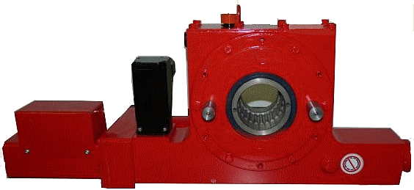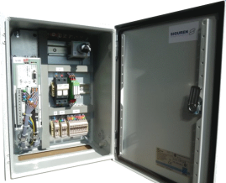

Hoist Power Supply

Hoist Controls

SIGUREN UNIT Controls

Authorization

Commands

Motor & Brake Power

*Figure 3: General electrical configuration*

## FUNCTIONAL STATES

A classic winch equipped with a SIGUREN UNIT® typically consists of the following parts:

Motor Brake

Torque Limiter

Gearbox

**CF**

**CLC**

**SIGUREN UNIT®**

HS Line

LS Line

**CMS**

**CS**

Load

Drum

***CS : Static Torque at the Drum***

***CF : Brake Torque***

***CMS : MS Braking Torque***

***CLC : Torque Limiter Slippage Torque***

### At Stop

During no movement, the load is hеld by the service brake. No torque on SIGUREN UNIT® during this state.

**CS**

**CF**

### Follow-up

During the follow-up phase down or up direction, the load is hold by the winch motor. The SIGUREN UNIT® follows the movement of the drum.

**CLC**

**CS**

### Electrical or mechanical failure

When the power train loses the control of the drum (eg shaft rupture or electrical failure), the MS triggers, because it is not able to follow the resulting acceleration. The load is arrested and holds by the SIGUREN UNIT®. During the braking, the torque Cms can reach 2.5xCs (Damping MS) or 1.4 to 2 x Cs (Friction MS), depending on the remaining inertia and on the behaviour of the motor and brake (energized or not).

**CS**

**CMS**

### Overspeed

The SIGUREN UNIT® is monitoring the actual speed of the drum. Should an over speed occurs without excessive acceleration; it detects it and acts on the hoist controls. If the hoist controls fail to stop the movement, it will arrest the load.

**CS**

**CMS**

**CLC**

### Recovery

By turning the SIGUREN UNIT® shaft, it is possible to lower / lift the load. If still active, the service brake can be opened without any risk. At full load, the raising torque is approximately 3 times bigger than the lowering torque.

Optionally, the SIGUREN UNIT® can be equipped with an electrical, pneumatical or hydraulic recovery built-in facility or a recovery drive can be supplied separately.

Service Brake opened

**CS**

**CMS**

# HOW TO SELECT YOUR SIGUREN UNIT®

## SIGUREN UNIT® TYPE SELECTION DIAGRAM

[[1]](#footnote-1)

Is it possible  
 to put a torque limiter?

No

Yes

Is there important inertia after the torque limiter?

Yes

No

No

Is the rotation speed exceeding 35 RPM?

**Passive Friction**

**Hydraulic Damping MS**

Yes

**Static torque calculation Cs**

**See Table page 13**

**MS torque**

**CMS ≥ 2.5 x CS**

**MS torque**

**CMS ≥ 1.4 x CS**

## HYDRAULING DAMPING SIGUREN UNIT®

The main criterion is the damping torque at full speed Vmax. The starting point to define this torque is the full load static torque at the drum (or at the MS wheel) Cs, without taking into account the efficiency.

Gearbox

Torque Limiter

Motor Brake

**CLC**

**CF**

SIGUREN UNIT®

HS Line

LS Line

CMS

CS

Fc

Ø D



Load

In order to be able to lift the full load, the torque limiter slippage point CLC should be set to:

**CLC≥ 1.2 x CS**

The damping torque (CMS) at full speed Vmax is set to:

**CMS≥ (CS+ CLC) x 1.13** or approximately **CMS ≥ 2.5 x CS**

The Hydraulic Damping SIGUREN UNIT® is intended only for kinematic chains with low inertia, where the system is compatible with a stop in 30° of rotation at the SIGUREN UNIT® wheel.

Generally, there should not be brake between the torque limiter and the SIGUREN UNIT® and the maximum speed of rotation of this later should not exceed 30 to 35 RPM.

## PASSIVE FRICTION SIGUREN UNIT®

The Passive Friction SIGUREN UNIT® is directly selected to ensure sufficient torque to stop the full load.

Generally, **CMS ≥ 1.4 x CS**

The speed at the SIGUREN UNIT® wheel can be up to 100 RPM.

***See Table next page.***

# SIGUREN UNIT® SIZE

|  |  |  |  |
| --- | --- | --- | --- |
| **MS size** | **Maximal braking torque : Hydraulic Damping MS** | **Maximal braking torque : Passive Friction MS** | **Recovery option : Lifting capacity** |
|  | **CMS\_hyd** | **CMS\_fri** | **CMS\_rec** |
| **Units** | Nm | Nm | Nm |
| **MS0** | 4 000 | 2 400 | 1 600 |
| **MS1** | 9 500 | 6 100 | 3 800 |
| **MS2** | 18 500 | 12 600 | 7 400 |
| **MS3** | 32 000 | 23 000 | 1 2 800 |
| **MS4** | 50 750 | 40 000 | 20 300 |
| **MS5** | 75 750 | 63 600 | 30 300 |
| **MS6** | 148 000 | 130 200 | 59 200 |
| **MS7** | 255 000 | 225 000 | 102 200 |

# CODIFICATION

|  |  |  |  |  |  |  |  |  |  |  |  |  |  |  |  |  |  |  |
| --- | --- | --- | --- | --- | --- | --- | --- | --- | --- | --- | --- | --- | --- | --- | --- | --- | --- | --- |
| **M** | **S** | **1** | **L** | **2** | **3** | **4** | **5** | **6** | **7** | **8** | **9** | **/** | **10** | **11** | **12** | **13** | **14** | **15** |

***Example*** *: MS0 L F R P C 1 S 6 1 / 5 TS*

|  |  |  |  |  |  |  |  |  |  |  |  |  |  |  |  |  |  |  |
| --- | --- | --- | --- | --- | --- | --- | --- | --- | --- | --- | --- | --- | --- | --- | --- | --- | --- | --- |
| **M**  *Example :* | **S** | **0** | **L** | **F** | **R** | **P** | **C** | **1** | **S** | **6** | **1** | **/** | **5** | **TL** | **TS** | **CP** | **C** | **CD** |

Motosuiveur®

1. Size 0

Lifting series

1. Passive friction type
2. Recovery mechanism included
3. Bearing with mounting Plate
4. Clockwise rotation
5. SIGUREN UNIT® reaction arm in position 1
6. SIGUREN UNIT® driven by a Splined shaft
7. SIGUREN UNIT® motor in position 6
8. Power Supply voltage 230 VAC I+N
9. Recovery mechanism in position 5
10. With torque limiter
11. Cabinet including Touchscreen
12. Polyesther enclosure
13. Harting clubs
14. Separated command

|  |  |  |  |
| --- | --- | --- | --- |
| **1** | **SIZE (cf. §3)** | | |
| Hydraulic damping | **0/ 1/ 2/ 3/ 4/ 5/ 6** | |
| Passive friction | **0/ 1/ 2/ 3/ 4/ 5/ 6/ 7** | |
| **2** | **TYPE (cf. §5)** | | |
| Hydraulic damping | **D** | |
| Passive friction | **F** | |
| Elastomer damping | **E** | |
| **3** | **RECOVERY (cf. §6)** | | |
| Integrated Electrical Recovery Mechanism | **R** | |
| Electrical Recovery Tool Included | **E** | |
| Manual Recovery Tool Included | **M** | |
| Not Applicable | **X** | |
| **4** | **MOUNTING TYPE (cf. §7)** | | |
| Bearing with mounting plate | **P** | |
| Foot mounted bearing (only for passive friction) | **F** | |
| Shaft mounted with reaction arm on side | **A** | |
| Shaft mounted with reaction arm support | **S** | |
| **5** | **ROTATION DIRECTION AT LOWERING (cf. §8)** | | |
| Clockwise | **C** | |
| Anti-clockwise | **A** | |
| **6** | **SIGUREN UNIT® REACTION ARM POSITION (cf. §10)** | | |
| **Hydraulic damping** | | |
| Bearing with mounting plate | **1** | |
| Shaft mounted with reaction arm on side | **1/ 2/ 3/ 4/ 5/ 6/ 7/ 8/ 9/ 10/ 11/ 12** | |
| Shaft mounted with reaction arm support | **1/ 2** | |
| ***Passive friction*** | | |
| Bearing with mounting plate | **1/ 2/ 3** | |
| Foot mounted bearing | **1/ 2** | |
| Shaft mounted with reaction arm on side | **1/ 2/ 3/ 4/ 5/ 6/ 7/ 8/ 9/ 10/ 11/ 12** | |
| Shaft mounted with reaction arm support | **1/ 2/ 3** | |
| **7** | **SIGUREN UNIT® DRIVING TYPE (cf. §11)** | | |
| Splined shaft | **S** | |
| Flange (only for bearing SIGUREN UNIT® type) | **F** | |
| **8** | **SIGUREN UNIT® MOTOR POSITION (cf. §12)** | | |
| **1/ 2/ 3/ 4/ 5/ 6/ 7/ 8/ 9/ 10/ 11** | | |
| **9** | **POWER SUPPLY VOLTAGE** | | |
| 230 VAC I+N | | **1** |
| 400VAC III | | **2** |
| 230-400VAC III+N | | **3** |
|  | **OPTIONS (cf. §13)** | | |
| **10** | Recovery mech. position | | **1/ 2/ 3/ 4/ 5/ 6/ 7** |
| **11** | Torque limiter (1) (only for passive friction MS) | | **TL** |
| **12** | Touchscreen | | **TS** |
| **13** | Steel enclosure | | **CT** |
| Stainless steel enclosure | | **CI** |
| Polyesther enclosure | | **CP** |
| Plate enclosure | | **P** |
| **14** | Terminal blocks | | **B** |
| Harting Plugs | | **C** |
| **15** | Separated commands (Recovery mechanism version only) | | **CD** |

(1) :The Torque Limiter is mandatory with Hydraulic Damping SIGUREN UNIT®

# SIGUREN UNIT® TYPE

## HYDRAULIC DAMPING SIGUREN UNIT®

|  |
| --- |
| **C:\Documents and Settings\A\Bureau\illustration MS hydraulique\29-05-13\MS hydraulique face.emf** |
| **D** |

*Figure 4: Hydraulic damping SIGUREN UNIT®*

## PASSIVE FRICTION SIGUREN UNIT®

|  |
| --- |
| C:\Documents and Settings\A\Bureau\illustration MS friction\29-05-13\MS friction face.emf |
| **F** |

*Figure 5: Passive friction SIGUREN UNIT®*

# RECOVERY

The purpose of the recovery system is to lower the load on a safe place if a component of the overall lifting equipment is damaged or unavailable.

|  |
| --- |
| **C:\Documents and Settings\A\Bureau\illustration MS hydraulique\29-05-13\MS-hydraulique-recovery-isometrique.emf** |
| **R** |

*Figure 6: SIGUREN UNIT® including recovery mechanism*

# MOUNTING TYPE

## HYDRAULIC DAMPING SIGUREN UNIT®

|  |
| --- |
| C:\Documents and Settings\A\Bureau\illustration MS hydraulique\29-05-13\MS-hydraulique-porteur-flasque-isometrique.emf |
| **P** |

*Figure 7: Bearing with mounting plate*

|  |  |
| --- | --- |
| C:\Documents and Settings\A\Bureau\illustration MS hydraulique\29-05-13\MS-hydraulique-flottant-bras_cote_isometrique.emf | C:\Documents and Settings\A\Bureau\illustration MS hydraulique\29-05-13\MS-hydraulique-flottant-support_bras-isometrique.emf |
| **A** | **S** |
| *Figure 8: Shaft mounted with reaction arm on side* | *Figure 9: Shaft mounted with reaction arm support* |

## PASSIVE FRICTION SIGUREN UNIT®

|  |  |
| --- | --- |
| **C:\Documents and Settings\A\Bureau\illustration MS friction\29-05-13\MS_friction_porteur_patte-isometrique.emf** | **C:\Documents and Settings\A\Bureau\illustration MS friction\29-05-13\MS_friction_porteur_platine-isometrique.emf** |
| **F** | **P** |
| *Figure 10: Foot mounted bearing* | *Figure 11: Bearing with mounting plate* |

|  |  |
| --- | --- |
| C:\Documents and Settings\A\Bureau\illustration MS friction\29-05-13\MS_friction_flottant_bras-isometrique.emf | C:\Documents and Settings\A\Bureau\illustration MS friction\29-05-13\MS_friction_flottant_support-bras-isometrique.emf |
| **A** | **S** |
| *Figure 12: Shaft mounted with reaction arm on side* | *Figure 13: Shaft mounted with reaction arm support* |

# DIRECTION CHOICE OF THE ROTATION AT LOWERING

## CLOCKWISE

|  |
| --- |
|  |
| **C** |

*Figure 14: Clockwise*

## ANTICLOCKWISE

|  |
| --- |
|  |
| **A** |

*Figure 15: Anticlockwise*

# SIGUREN UNIT® POSITION CHOICE

## HYDRAULIC DAMPING SIGUREN UNIT®

|  |
| --- |
| Prohibited positions  Authorized positions  **135 °** |
| *Figure 16: Hydraulic damping SIGUREN UNIT® positions* |

## PASSIVE FRICTION SIGUREN UNIT®

Passive friction SIGUREN UNIT® can be mounted in all positions.

# SIGUREN UNIT® REACTION ARM POSITION CHOICE

## HYDRAULIC DAMPING SIGUREN UNIT®

### Position of mounting plate

|  |
| --- |
|  |
| **1** |
| *Figure 17: Bearing Hydraulic damping SIGUREN UNIT® with mounting plate* |

### Position of reaction arm

|  |
| --- |
| α° |
| **1 to 12 (See tables below)** |
| *Figure 18: Shaft mounted Hydraulic damping SIGUREN UNIT® with reaction arm on side* |

For SIGUREN UNIT® size 0, 1, 2, 3 and 4:

|  |  |  |  |  |  |  |  |  |
| --- | --- | --- | --- | --- | --- | --- | --- | --- |
| **Position n°** | **1** | *2(1)* | **3** | **4** | **5** | **6** | **7** | *8(1)* |
| **α°** | **0** | *45* | **90** | **135** | **180** | **225** | **270** | *315* |

1. Special positions

For SIGUREN UNIT® size 5 and 6:

|  |  |  |  |  |  |  |  |  |  |  |  |  |
| --- | --- | --- | --- | --- | --- | --- | --- | --- | --- | --- | --- | --- |
| **Position n°** | **1** | **2** | *3(1)* | **4** | **5** | **6** | **7** | **8** | **9** | **10** | *11(1)* | **12** |
| **α°** | **0** | **30** | *60* | **90** | **120** | **150** | **180** | **210** | **240** | **270** | *300* | **330** |

1. Special positions

### Position of reaction arm support

|  |  |
| --- | --- |
|  |  |
| **1** | **2** |

*Figure 19: Shaft mounted Hydraulic damping SIGUREN UNIT® with reaction arm support*

## PASSIVE FRICTION SIGUREN UNIT®

### Position of mounting plate

|  |  |
| --- | --- |
|  |  |
| **1** | **2** |
|  | |
| **3** | |

*Figure 20: Bearing passive friction SIGUREN UNIT® with mounting plate*

### Feet position

|  |  |
| --- | --- |
|  |  |
| **1** | **2** |
| *Figure 21: Foot Bearing passive friction SIGUREN UNIT®* | |

### Position of reaction arm

|  |
| --- |
| α° |
| **1 to 12 (See tables below)** |
| *Figure 22: Shaft mounted Passive friction SIGUREN UNIT® with reaction arm on side* |

For SIGUREN UNIT® size 0, 1, 2, 3 and 4:

|  |  |  |  |  |  |  |  |  |
| --- | --- | --- | --- | --- | --- | --- | --- | --- |
| **Position n°** | **1** | **2** | **3** | **4** | **5** | **6** | **7** | *8(1)* |
| **α°** | **0** | **45** | **90** | **135** | **180** | **225** | **270** | *315* |

1. Special positions

For SIGUREN UNIT® size 5, 6 and 7:

|  |  |  |  |  |  |  |  |  |  |  |  |  |
| --- | --- | --- | --- | --- | --- | --- | --- | --- | --- | --- | --- | --- |
| **Position n°** | **1** | **2** | **3** | **4** | **5** | **6** | **7** | **8** | **9** | **10** | *11(1)* | **12** |
| **α°** | **0** | **30** | **60** | **90** | **120** | **150** | **180** | **210** | **240** | **270** | *300* | **330** |

1. Special positions

### Position of reaction arm support

|  |  |
| --- | --- |
|  |  |
| **1** | **2** |
|  | |
| **3** | |
| *Figure 23: Reaction arm support positions on passive friction SIGUREN UNIT®* | |

# CHOICE OF THE SIGUREN UNIT® DRIVING TYPE

|  |  |
| --- | --- |
| C:\Documents and Settings\A\Bureau\illustration MS hydraulique\29-05-13\entrainement cannelure.emf | C:\Documents and Settings\A\Bureau\illustration MS hydraulique\29-05-13\entrainement flasque.emf |
| **S** | **F** |
| *Figure 24: Splined shaft* | *Figure 25: Flange* |

# SIGUREN UNIT® MOTOR POSITION CHOICE

|  |
| --- |
| **9**  **8**  **11**  **10**  **1**  **2**  **3**  **4**  **7**  **6**  **5** |
| **1 to 11** |
| *Figure 26: SIGUREN UNIT® motor position* |

# OPTIONS

## RECOVERY MOTOR POSITION

|  |
| --- |
| **5**  **4**  **7**  **6**  **3**  **2**  **1** |
| **1 to 7** |
| *Figure 27: SIGUREN UNIT® Recovery motor position* |

**MS motor/ Recovery motor positions compatibility**

|  |  |  |  |  |  |  |  |
| --- | --- | --- | --- | --- | --- | --- | --- |
| **MS motor position** | **Recovery motor position** | | | | | | |
| 1 | 1 | 2 | 3 | 4 | 5 | 6 | 7 |
| 2 | 1 | 2 | 3 | - | 5 | - | 7 |
| 3 | - | 2 | 3 | 4 | 5 | 6 | 7 |
| 4 | 1 | 2 | 3 | - | 5 | - | 7 |
| 5 | - | 2 | 3 | 4 | 5 | 6 | 7 |
| 6 | - | - | 3 | 4 | 5 | - | 7 |
| 7 | 1 | 2 | - | 4 | 5 | 6 | 7 |
| 8 | 1 | 2 | 3 | - | 5 | - | 7 |
| 9 | 1 | 2 | 3 | - | - | - | 7 |
| 10 | 1 | 2 | 3 | - | 5 | - | 7 |
| 11 | 1 | 2 | 3 | 4 | 5 | 6 | - |

## TOUCH SCREEN

The display has two functions:

* Display the data and main information (speed, current functioning mode, state of the motion authorization signal, fault history, mechanical functioning time)
* Enter data in SIGUREN UNIT® system by a qualified operator (over speed threshold, acceleration deceleration)
* SWP (Safe Working Periods) calculation according to FEM 9.755

|  |  |  |
| --- | --- | --- |
| O:\INTERNE\LA007 MARKETING PRODUITS\CATALOGUE\Final version 2013-0\touch screen.gif | | |
| *Figure 28: Touchscreen* | | |
|  | |
|  |  | | |
|  |  | | |
| *Figure 29: Touchscreen interface examples* | | | |

## TORQUE LIMITER

The use a torque limiter between the main motor and the gear box is mandatory with a hoist equipped of a hydraulic braking SIGUREN UNT®.

It is optional in the case of use a passive friction braking SIGUREN UNIT®. The torque limiter cuts the static and dynamic overloads. The torque limiter is delivered factory rated to the value necessary to the application.

|  |
| --- |
|  |
| *Figure 30: Torque limiters example* |

# DIMENSIONS

## SIGUREN UNIT® HYDRAULIC DAMPING

### Bearing version

C:\Documents and Settings\A\Bureau\illustration MS hydraulique\29-05-13\MS-hydraulique-porteur-flasque.emf

|  |  |  |  |  |  |  |  |
| --- | --- | --- | --- | --- | --- | --- | --- |
| **Size**  **Dim. (mm)** | **MS 0** | **MS 1** | **MS 2** | **MS 3** | **MS 4** | **MS 5** | **MS 6** |
| A1 | 84,5 | 110 | 137,5 | 165 | 192,5 | 220 | 275 |
| A2 | 114,5 | 150 | 187,5 | 225 | 262,5 | 300 | 375 |
| A3 | 97 | 124 | 155 | 186 | 216 | 246 | 305 |
| A4 | 126,5 | 164 | 202,5 | 243 | 282,5 | 320 | 400 |
| A5 | 258,5 | 333 | 436,5 | 506 | 570,5 | 652 | 782 |
| A6 | 511,5 | 632,5 | 783 | 933 | 1095 | 1236 | 1514 |
| A7 | 196 | 231,5 | 290 | 345 | 409 | 456 | 564 |
| A8 | 216,5 | 272 | 333 | 393 | 458 | 519 | 632 |
| A9 | 194 | 248 | 322 | 372 | 432 | 492 | 610 |
| A10 | 97 | 124 | 161 | 186 | 216 | 246 | 305 |
| ØA11 H8 | 10 | 12 | 16 | 16 | 20 | 25 | 30 |
| ØA12 | 11 | 11 | 13 | 13 | 13 | 17 | 17 |
|  |  |  |  |  |  |  |  |
| C1 | 262 | 323 | 410 | 484 | 562 | 646 | 788 |
| C2 | 120 | 150 | 200 | 220 | 250 | 300 | 350 |
| C3 | 90 | 120 | 150 | 170 | 200 | 240 | 280 |
| C4 | 80 | 100 | 150 | 150 | 180 | 220 | 250 |
| C5 | 40 | 50 | 75 | 75 | 90 | 110 | 125 |
| C7 | 14 | 16 | 18 | 18 | 22 | 22 | 26 |
|  |  |  |  |  |  |  |  |
| **Driving flange** | | | | | | | |
| B1 | 103 | 122 | 155 | 173 | 208 | 238 | 287 |
| ØB2 H8 | 40 | 64 | 82 | 90 | 105 | 125 | 170 |
| B3 (1) | 125 | 170 | 210 | 260 | 280 | 350 | 440 |
| ØB4 (1) | 150 | 200 | 250 | 300 | 340 | 400 | 500 |
| B5 | 40 | 45 | 50 | 60 | 70 | 75 | 90 |
| M (kg) | 37 | 73 | 136 | 227 | 354 | 530 | 1000 |
|  |  |  |  |  |  |  |  |
| **Driving spline** | | | | | | | |
| D1 | 103 | 122 | 155 | 173 | 208 | 238 | 287 |
| D2 | 25 | 31 | 36 | 44 | 50 | 58 | 72 |
| D3 | 53 | 60 | 83 | 85 | 108 | 122 | 143 |
| Ø D4 H7 | 61 | 81 | 102 | 122 | 142 | 162 | 204 |
| Ø D5 H7 | 54 | 72 | 92 | 110 | 128 | 148 | 180 |
| D6 (DIN 5480) (2) | 60x28x2 | 80x25x3 | 100x32x3 | 120x28x4 | 140x26x5 | 160x30x5 | 200x24x8 |
| M (kg) | 34 | 68 | 125 | 210 | 331 | 492 | 930 |
|  |  |  |  |  |  |  |  |
| y1 | 6 | 6 | 6 | 8 | 8 | 8 | 8 |
| y2 | 2 | 2 | 2 | 4 | 4 | 4 | 4 |
| y3 | 8 | 8 | 8 | 8 | 8 | 10 | 10 |

*Dimensions subject to engineering changes*

1. Standard specifications (others possible on demand)
2. Splines max. size. Other sizes or transmission connections (keyed …) are possible.

### Shaft mounted with reaction arm on side

C:\Documents and Settings\A\Bureau\illustration MS hydraulique\29-05-13\MS-hydraulique-flottant-bras_cote-30-05-13.emf

|  |  |  |  |  |  |  |  |
| --- | --- | --- | --- | --- | --- | --- | --- |
| **Size**  **Dim. (mm)** | **MS 0** | **MS 1** | **MS 2** | **MS 3** | **MS 4** | **MS 5** | **MS 6** |
| A1 | 84,5 | 110 | 137,5 | 165 | 192,5 | 220 | 275 |
| A2 | 114,5 | 150 | 187,5 | 225 | 262,5 | 300 | 375 |
| A3 | 97 | 124 | 155 | 186 | 216 | 246 | 305 |
| A4 | 180 +/-2 | 225 +/- 3 | 280 +/- 3,5 | 340 +/- 4 | 385 +/- 4 | 440 +/- 4 | 550 +/- 4,5 |
| A5 | 342 | 444 | 569 | 673 | 753 | 862 | 1032 |
| A6 | 511,5 | 632,5 | 783 | 933 | 1095 | 1236 | 1514 |
| A7 | 196 | 231,5 | 290 | 345 | 409 | 456 | 564 |
| A8 | 216,5 | 272 | 333 | 393 | 458 | 519 | 632 |
| A9 | 194 | 248 | 322 | 372 | 432 | 492 | 610 |
| A10 | 97 | 124 | 161 | 186 | 216 | 246 | 305 |
|  |  |  |  |  |  |  |  |
| D1 | 90 | 112 | 134 | 158 | 182 | 212 | 254 |
| D2 | 25 | 31 | 36 | 44 | 50 | 58 | 72 |
| D3 | 40 | 50 | 62 | 70 | 82 | 96 | 110 |
| Ø D4 H7 | 61 | 81 | 102 | 122 | 142 | 162 | 204 |
| Ø D5 H7 | 54 | 72 | 92 | 110 | 128 | 148 | 180 |
| D6 (DIN 5480) (1) | 60x28x2 | 80x25x3 | 100x32x3 | 120x28x4 | 140x26x5 | 160x30x5 | 200x24x8 |
| Ø D7 H8 | 18 | 25 | 30 | 35 | 40 | 50 | 60 |
| D8 | 18 | 20 | 23 | 29 | 32 | 36 | 44 |
| D9 | 45 | 56 | 68,5 | 81,5 | 94 | 108 | 133 |
|  |  |  |  |  |  |  |  |
| M (kg) | 31 | 64 | 120 | 201 | 316 | 480 | 897 |

*Dimensions subject to engineering changes*

1. Splines max. size. Other sizes or transmission connections (keyed …) are possible.

### Shaft mounted with reaction arm support

C:\Documents and Settings\A\Bureau\illustration MS hydraulique\29-05-13\MS-hydraulique-flottant-support_bras-30-05-13.emf

|  |  |  |  |  |  |  |  |
| --- | --- | --- | --- | --- | --- | --- | --- |
| **Size**  **Dim. (mm)** | **MS 0** | **MS 1** | **MS 2** | **MS 3** | **MS 4** | **MS 5** | **MS 6** |
| A1 | 84,5 | 110 | 137,5 | 165 | 192,5 | 220 | 275 |
| A2 | 114,5 | 150 | 187,5 | 225 | 262,5 | 300 | 375 |
| A3 | 97 | 124 | 155 | 186 | 216 | 246 | 305 |
| A4 | 147,5 | 195 | 247,5 | 295 | 342,5 | 390 | 480 |
| A5 | 300 | 389 | 522 | 600 | 677 | 777 | 927 |
| A6 | 511,5 | 632,5 | 783 | 933 | 1095 | 1236 | 1514 |
| A7 | 196 | 231,5 | 290 | 345 | 409 | 456 | 564 |
| A8 | 216,5 | 272 | 333 | 393 | 458 | 519 | 632 |
| A9 | 194 | 248 | 322 | 372 | 432 | 492 | 610 |
| A10 | 97 | 124 | 161 | 186 | 216 | 246 | 305 |
|  |  |  |  |  |  |  |  |
| D1 | 90 | 112 | 134 | 158 | 182 | 212 | 254 |
| D2 | 25 | 31 | 36 | 44 | 50 | 58 | 72 |
| D3 | 40 | 50 | 62 | 70 | 82 | 96 | 110 |
| Ø D4 H7 | 61 | 81 | 102 | 122 | 142 | 162 | 204 |
| Ø D5 H7 | 54 | 72 | 92 | 110 | 128 | 148 | 180 |
| D6 (DIN 5480) (1) | 60x28x2 | 80x25x3 | 100x32x3 | 120x28x4 | 140x26x5 | 160x30x5 | 200x24x8 |
| Ø D7 | 20 | 26 | 32 | 37 | 47 | 55 | 64 |
| D8 | 90 | 110 | 134 | 150 | 180 | 205 | 250 |
|  |  |  |  |  |  |  |  |
| M (kg) | 30 | 62 | 115 | 195 | 305 | 460 | 868 |

*Dimensions subject to engineering changes*

1. Splines max. size. Other sizes or transmission connections (keyed …) are possible.

## PASSIVE FRICTION

### Foot mounted bearing

C:\Documents and Settings\A\Bureau\illustration MS friction\29-05-13\MS_friction_porteur_patte.emf

|  |  |  |  |  |  |  |  |  |
| --- | --- | --- | --- | --- | --- | --- | --- | --- |
| **Size**  **Dim. (mm)** | **MS 0** | **MS 1** | **MS 2** | **MS 3** | **MS 4** | **MS 5** | **MS 6** | **MS 7** |
|  |  |  |  |  |  |  |  |  |
| A1 | 84,5 | 110 | 137,5 | 165 | 192,5 | 220 | 275 | 330 |
| A2 | 119,5 | 150 | 187,5 | 225 | 262,5 | 300 | 375 | 450 |
| A3 | 239 | 300 | 375 | 450 | 525 | 600 | 750 | 900 |
| A4 | 391 | 432 | 531 | 594 | 691 | 761 | 892 | 1069 |
| A5 | 294 | 333 | 427 | 490 | 580 | 650 | 780 | 954 |
| A6 | 194 | 248 | 322 | 372 | 432 | 492 | 610 | 734 |
| A7 | 97 | 124 | 161 | 186 | 216 | 246 | 305 | 367 |
| ØA8 H8 | 10 | 12 | 16 | 16 | 20 | 25 | 30 | 35 |
| ØA9 | 11 | 11 | 13 | 13 | 13 | 17 | 17 | 22 |
|  |  |  |  |  |  |  |  |  |
| C1 | 339 | 430 | 535 | 640 | 745 | 860 | 1070 | 1280 |
| C2 | 295 | 375 | 464 | 560 | 655 | 750 | 930 | 1120 |
| C3 | 50 | 50 | 70 | 90 | 90 | 100 | 110 | 150 |
| C4 | 80 | 100 | 120 | 140 | 160 | 180 | 220 | 260 |
| ØC5 | 13 | 16 | 18 | 23 | 27 | 33 | 40 | 43 |
|  |  |  |  |  |  |  |  |  |
| **Driving flange** | | | | | | | | |
| B1 | 117 | 130 | 163 | 183 | 220 | 254 | 305 | 370 |
| ØB2 H8 | 40 | 64 | 82 | 90 | 105 | 125 | 170 | 195 |
| B3 (1) | 125 | 170 | 210 | 260 | 280 | 350 | 440 | 520 |
| ØB4 (1) | 150 | 200 | 250 | 300 | 340 | 400 | 500 | 600 |
| B5 (1) | 40 | 45 | 50 | 60 | 70 | 75 | 90 | 100 |
| M (kg) | 41 | 69 | 133 | 224 | 349 | 518 | 967 | 1645 |
|  |  |  |  |  |  |  |  |  |
| **Driving spline** | | | | | | | | |
| D1 | 117 | 130 | 163 | 183 | 220 | 254 | 305 | 370 |
| D2 | 25 | 31 | 36 | 44 | 50 | 58 | 72 | 95 |
| D3 | 67 | 68 | 91 | 95 | 120 | 138 | 161 | 180 |
| Ø D4 H7 | 61 | 81 | 102 | 122 | 142 | 162 | 204 | 244 |
| Ø D5 H7 | 54 | 72 | 92 | 110 | 128 | 148 | 180 | 220 |
| D6 (DIN 5480) (2) | 60x28x2 | 80x25x3 | 100x32x3 | 120x28x4 | 140x26x5 | 160x30x5 | 200x24x8 | 240x28x8 |
| M (kg) | 39 | 65 | 123 | 208 | 327 | 482 | 900 | 1550 |
|  |  |  |  |  |  |  |  |  |
| y1 | 6 | 6 | 6 | 8 | 8 | 8 | 8 | 8 |
| y2 | 2 | 2 | 2 | 4 | 4 | 4 | 4 | 4 |

*Dimensions subject to engineering changes*

1. Standard specifications (others possible on demand)
2. Splines max. size. Other sizes or transmission connections (keyed …) are possible.

### Bearing with mounting plate

C:\Documents and Settings\A\Bureau\illustration MS friction\29-05-13\MS_friction_porteur_platine.emf

|  |  |  |  |  |  |  |  |  |
| --- | --- | --- | --- | --- | --- | --- | --- | --- |
| **Size**  **Dim. (mm)** | **MS 0** | **MS 1** | **MS 2** | **MS 3** | **MS 4** | **MS 5** | **MS 6** | **MS 7** |
|  |  |  |  |  |  |  |  |  |
| A1 | 84,5 | 110 | 137,5 | 165 | 192,5 | 220 | 275 | 330 |
| A2 | 119,5 | 150 | 187,5 | 225 | 262,5 | 300 | 375 | 450 |
| A2 mini (2) | 97 | 124 | 161 | 186 | 216 | 246 | 305 | 367 |
| A3 | 131,5 | 164 | 202,5 | 243 | 282,5 | 320 | 400 | 480 |
| A3 mini (2) | 109 | 138 | 176 | 204 | 236 | 266 | 330 | 397 |
| A4 | 260,5 | 333 | 436,5 | 506 | 570,5 | 652 | 782 | 1015 |
| A5 | 391 | 432 | 531 | 594 | 691 | 761 | 892 | 1069 |
| A6 | 294 | 333 | 427 | 490 | 580 | 650 | 780 | 954 |
| A7 | 194 | 248 | 322 | 372 | 432 | 492 | 610 | 734 |
| A8 | 425 | 469,5 | 575 | 650 | 756 | 838 | 981 | 1177 |
| A9 | 131 | 161,5 | 205 | 242 | 281 | 323 | 394 | 475 |
| ØA10 | 11 | 11 | 13 | 13 | 13 | 17 | 17 | 22 |
| ØA11 H8 | 10 | 12 | 16 | 16 | 20 | 25 | 30 | 35 |
|  |  |  |  |  |  |  |  |  |
| C1 | 262 | 323 | 410 | 484 | 562 | 646 | 788 | 950 |
| C2 | 120 | 150 | 200 | 220 | 250 | 300 | 350 | 450 |
| C3 | 90 | 120 | 150 | 170 | 200 | 240 | 280 | 340 |
| C4 | 80 | 100 | 150 | 150 | 180 | 220 | 250 | 300 |
| C5 | 40 | 50 | 75 | 75 | 90 | 110 | 125 | 150 |
| C7 | 14 | 16 | 18 | 18 | 22 | 22 | 26 | 33 |
|  |  |  |  |  |  |  |  |  |
| **Driving flange** | | | | | | | | |
| B1 | 117 | 130 | 163 | 183 | 220 | 254 | 305 | 370 |
| ØB2 H8 | 40 | 64 | 82 | 90 | 105 | 125 | 170 | 195 |
| B3 (1) | 125 | 170 | 210 | 260 | 280 | 350 | 440 | 520 |
| ØB4 (1) | 150 | 200 | 250 | 300 | 340 | 400 | 500 | 600 |
| B5 (1) | 40 | 45 | 50 | 60 | 70 | 75 | 90 | 100 |
| M (kg) | 42 | 72 | 137 | 229 | 353 | 524 | 985 | 1671 |
|  |  |  |  |  |  |  |  |  |
| **Driving spline** | | | | | | | | |
| D1 | 117 | 130 | 163 | 183 | 220 | 254 | 305 | 370 |
| D2 | 25 | 31 | 36 | 44 | 50 | 58 | 72 | 95 |
| D3 | 67 | 68 | 91 | 95 | 120 | 138 | 161 | 180 |
| Ø D4 H7 | 61 | 81 | 102 | 122 | 142 | 162 | 204 | 244 |
| Ø D5 H7 | 54 | 72 | 92 | 110 | 128 | 148 | 180 | 220 |
| D6 (DIN 5480) (3) | 60x28x2 | 80x25x3 | 100x32x3 | 120x28x4 | 140x26x5 | 160x30x5 | 200x24x8 | 240x28x8 |
| M (kg) | 40 | 67 | 127 | 213 | 331 | 488 | 917 | 1578 |
|  |  |  |  |  |  |  |  |  |
| y1 | 2 | 2 | 2 | 4 | 4 | 4 | 4 | 4 |
| y2 | 6 | 6 | 6 | 8 | 8 | 8 | 8 | 8 |
| y3 | 8 | 8 | 8 | 8 | 8 | 10 | 10 | 12 |

*Dimensions subject to engineering changes*

1. Standard specifications (others possible on demand)
2. Special realisation -modification necessary
3. Splines max. size. Other sizes or transmission connections (keyed …) are possible.

### Shaft mounted with reaction arm support

C:\Documents and Settings\A\Bureau\illustration MS friction\29-05-13\MS_friction_flottant_support_bras.emf

|  |  |  |  |  |  |  |  |  |
| --- | --- | --- | --- | --- | --- | --- | --- | --- |
| **Size**  **Dim. (mm)** | **MS 0** | **MS 1** | **MS 2** | **MS 3** | **MS 4** | **MS 5** | **MS 6** | **MS 7** |
|  |  |  |  |  |  |  |  |  |
| A1 | 84,5 | 110 | 137,5 | 165 | 192,5 | 220 | 275 | 330 |
| A2 | 119,5 | 150 | 187,5 | 225 | 262,5 | 300 | 375 | 450 |
| A3 | 147,5 | 195 | 247,5 | 295 | 342,5 | 390 | 480 | 575 |
| A4 | 302 | 389 | 524 | 600 | 676 | 777 | 927 | 1190 |
| A5 | 391 | 432 | 531 | 594 | 691 | 761 | 892 | 1069 |
| A6 | 294 | 333 | 427 | 490 | 580 | 650 | 780 | 954 |
| A7 | 194 | 248 | 322 | 372 | 432 | 492 | 610 | 734 |
|  |  |  |  |  |  |  |  |  |
| D1 | 104 | 120 | 142 | 168 | 194 | 228 | 272 | 340 |
| D2 | 25 | 31 | 36 | 44 | 50 | 58 | 72 | 95 |
| D3 | 54 | 58 | 70 | 80 | 94 | 112 | 128 | 150 |
| Ø D4 H7 | 61 | 81 | 102 | 122 | 142 | 162 | 204 | 244 |
| Ø D5 H7 | 54 | 72 | 92 | 110 | 128 | 148 | 180 | 220 |
| D6 (DIN 5480) (1) | 60x28x2 | 80x25x3 | 100x32x3 | 120x28x4 | 140x26x5 | 160x30x5 | 200x24x8 | 240x28x8 |
| Ø D7 | 20 | 26 | 32 | 37 | 47 | 55 | 64 | 70 |
| D8 | 90 | 110 | 134 | 150 | 180 | 205 | 250 | 310 |
|  |  |  |  |  |  |  |  |  |
| M (kg) | 38 | 65 | 12 | 202 | 315 | 473 | 895 | 1535 |

*Dimensions subject to engineering changes*

1. Splines max. size. Other sizes or transmission connections (keyed …) are possible.

### Shaft mounted with reaction on side

C:\Documents and Settings\A\Bureau\illustration MS friction\29-05-13\MS_friction_flottant_bras.emf

|  |  |  |  |  |  |  |  |  |
| --- | --- | --- | --- | --- | --- | --- | --- | --- |
| **Size**  **Dim. (mm)** | **MS 0** | **MS 1** | **MS 2** | **MS 3** | **MS 4** | **MS 5** | **MS 6** | **MS 7** |
|  |  |  |  |  |  |  |  |  |
| A1 | 84,5 | 110 | 137,5 | 165 | 192,5 | 220 | 275 | 330 |
| A2 | 119,5 | 150 | 187,5 | 225 | 262,5 | 300 | 375 | 450 |
| A3 | 180 +/-2 | 225 +/- 3 | 280 +/- 3,5 | 340 +/- 4 | 385 +/- 4 | 440 +/- 4 | 550 +/- 4,5 | 655 +/- 4,5 |
| A4 | 339 | 444 | 569 | 673 | 753 | 862 | 1032 | 1300 |
| A5 | 391 | 432 | 531 | 594 | 691 | 761 | 892 | 1069 |
| A6 | 294 | 333 | 427 | 490 | 580 | 650 | 780 | 954 |
| A7 | 194 | 248 | 322 | 372 | 432 | 492 | 610 | 734 |
|  |  |  |  |  |  |  |  |  |
| D1 | 104 | 120 | 142 | 168 | 194 | 228 | 272 | 340 |
| D2 | 25 | 31 | 36 | 44 | 50 | 58 | 72 | 95 |
| D3 | 54 | 58 | 70 | 80 | 94 | 112 | 128 | 150 |
| Ø D4 H7 | 61 | 81 | 102 | 122 | 142 | 162 | 204 | 244 |
| Ø D5 H7 | 54 | 72 | 92 | 110 | 128 | 148 | 180 | 220 |
| D6 (DIN 5480) (1) | 60x28x2 | 80x25x3 | 100x32x3 | 120x28x4 | 140x26x5 | 160x30x5 | 200x24x8 | 240x28x8 |
| Ø D7 H8 | 18 | 25 | 30 | 35 | 40 | 50 | 60 | 70 |
| D8 | 18 | 20 | 23 | 29 | 32 | 36 | 44 | 56 |
| D9 | 49 | 56 | 68,5 | 81,5 | 94 | 108 | 133 | 161,5 |
|  |  |  |  |  |  |  |  |  |
| M (kg) | 38 | 65 | 123 | 202 | 315 | 473 | 895 | 1535 |

*Dimensions subject to engineering changes*

1. Splines max. size. Other sizes or transmission connections (keyed …) are possible.

## DRUM SHAFT WITH SPLINES



|  |  |  |  |  |  |  |  |  |
| --- | --- | --- | --- | --- | --- | --- | --- | --- |
| **Size**  **Dim. (mm)** | **MS 0** | **MS 1** | **MS 2** | **MS 3** | **MS 4** | **MS 5** | **MS 6** | **MS 7** |
|  |  |  |  |  |  |  |  |  |
| D2 | 25 | 31 | 36 | 44 | 50 | 58 | 72 | 95 |
| D3 (DP) (1) | 53 | 60 | 83 | 85 | 108 | 122 | 143 | - |
| D3 (DA / DS) (1) | 40 | 50 | 62 | 70 | 82 | 96 | 110 | - |
| D3 (FP / FF) (1) | 67 | 68 | 91 | 95 | 120 | 138 | 161 | 180 |
| D3 (FA / FS) (1) | 54 | 58 | 70 | 80 | 94 | 112 | 128 | 146 |
| D10 | 24 | 30 | 35 | 43 | 49 | 57 | 71 | 94 |
| Ø D11 mini | 66 | 88 | 110 | 130 | 155 | 175 | 220 | 260 |
| Ø D12 H7/g6 | 61 | 81 | 102 | 122 | 142 | 162 | 204 | 244 |
| D13 DIN 5480 (2) | 60x28x2 | 80x25x3 | 100x32x3 | 120x28x4 | 140x26x5 | 160x30x5 | 200x24x8 | 240x28x8 |
| Ø D14 H7/g6 | 54 | 72 | 92 | 110 | 128 | 148 | 180 | 220 |
| D15 | 25 | 30 | 35 | 40 | 50 | 60 | 80 | 90 |
| D16 | M8 | M10 | M10 | M12 | M12 | M14 | M14 | M16 |
| E1 | 2 | 2 | 2 | 2 | 3 | 3 | 3 | 3 |
| E2 | 1 | 1 | 1,5 | 1,5 | 2 | 2 | 3 | 3 |
| R E3 maxi | 0,5 | 0,5 | 1 | 1 | 1,5 | 1,5 | 2 | 2 |

*Dimensions subject to engineering changes*

DP: spline shaft for hydraulic Damping – bearing version

DA/ DS: spline shaft for hydraulic Damping – shaft mounted version

FP/ FF: spline shaft for passive Friction – bearing version

FA/ FS: spline shaft for passive Friction – shaft mounted version

1. Splines max. size. Other sizes or transmission connections (keyed …) are possible.

# EXAMPLE OF CALCULATION

## EXAMPLE N°1–HYDRAULIC DAMPING SIGUREN UNIT®

**Hoist input data’s:**

* SWL = 19 700 kg
* Dead weight = 300 Kg
* Reeving = 4/1
* Drum diameter = 500 mm
* Gearbox ratio = 130
* Motor speed = 1500 rpm
* Is it possible to put a torque limiter? **Yes**
* Is there important inertia after the torque limiter? **No**
* Is the rotation speed at drum exceeding 35 rpm? **No, see calculation below (11.54  rpm < 35 rpm)**

**Hydraulic damping MS**

|  |  |  |  |  |
| --- | --- | --- | --- | --- |
| **Designation** | **Symbol** | **Value** | **Units** | **Formula** |
| ***Forces and torque*** | | | | |
| Load weight | WL | **19 700** | kg |  |
| Dead weight | WT | **300** | kg |  |
| Load+ dead weight | SWL | 20 000 | kg | =(WL+WT) |
| Gravity | g | **9,81** | m/s² |  |
| Lifting force | FL | 196 200 | N | =SWL\*g |
| Reewing ratio | im | **4** | - |  |
| Drum pitch diameter | D | **500** | mm |  |
| Gearbox ratio | ir | **130** | - |  |
| Force at driven rope strand | Fc | 49 050 | N | =SWL\*g/im |
| Static torque at drum | CS | 12 262.5 | Nm | =Fc\*D/2000 |
| ***Speeds*** | | | | |
| Speed at High Speed Line | SHSL | **1 500** | rpm |  |
| Speed at MS | SMS | 11.54 | rpm | =SHSL/ir |

**Size of the SIGUREN UNIT®:**

CMS= 2.5 x Cs = 2.5x 12 262.5 = **30 656 Nm**

According to table page 13, CMS=**30 656 Nm** < **32000 Nm** 🡪 **MS3**

## EXAMPLE N°2–PASSIVE FRICTION SIGUREN UNIT®

**Hoist input data’s:**

* SWL = 4 900 kg
* Dead weight = 100 Kg
* Reeving = 2/1
* Drum diameter = 250 mm
* Gearbox ratio = 60
* Motor speed = 3000 rpm
* Is it possible to put a torque limiter? **Yes**
* Is there important inertia after the torque limiter? **No**
* Is the rotation speed at drum exceeding 35 rpm? **Yes, see calculation below (50 rpm > 35 rpm)**

**Passive friction MS**

|  |  |  |  |  |
| --- | --- | --- | --- | --- |
| **Designation** | **Symbol** | **Value** | **Units** | **Formula / comment** |
| ***Forces and torques*** | | | | |
| Load weight | WL | **4 900** | kg |  |
| Dead weight | WT | **100** | kg |  |
| Load+ dead weight | SWL | 5 000 | kg | =(WL+WT) |
| Gravity | g | **9,81** | m/s² |  |
| Lifting force | FL | 49 050 | N | =SWL\*g |
| Reeving ratio | im | **2** | - |  |
| Drum pitch diameter | D | **250** | mm |  |
| Gearbox ratio | ir | **60** | - |  |
| Force at driven rope strand | Fc | 24 525 | N | =SWL\*g/im |
| Static torque at drum | CS | 3 065 | Nm | =Fc\*D/2000 |
| ***Speeds*** | | | | |
| Speed at High Speed Line | SHSL | **3 000** | Rpm |  |
| Speed at MS | SMS | 50 | Rpm | =SHSL/ir |

**Size of the MS:**

CMS mini= 1.4 x Cs = 1.4x 3 065 = **4 291 Nm**

According to table page 13, CMS=**4 291 Nm** < **6 100 Nm** 🡪 **MS1**

# POSITIONS, TYPES AND OPTIONS EXAMPLES

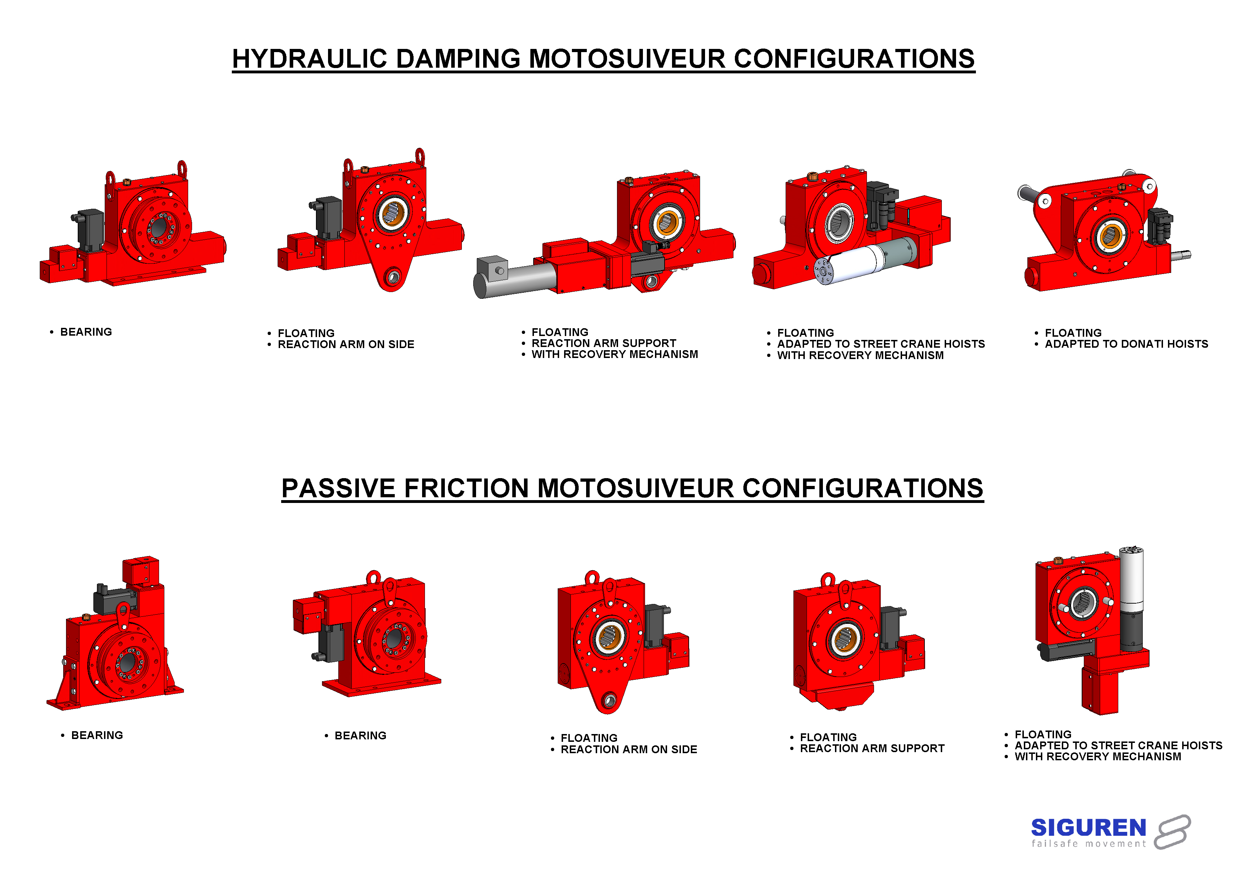

# ELECTRICAL INTERFACE

## BASIC LINE

## TOUCH SCREEN LINE



## RECOVERY LINE

***Our references***



Join our list of Clients that have already benefited from the SIGUREN UNIT® technology

**SIGUREN ENGINEERING**

Z.I. de la Tuillière

rue de la Traille

01700 MIRIBEL

France

Our website : [www.siguren.com](http://www.siguren.com)

Email : [contact@siguren.com](mailto:contact@siguren.com)





1. [↑](#footnote-ref-1)